**Parameters:**

* **Parameters holds Value at runtime**
* **Parameter is similar to Property, but Parameters is not a rule in Pega. Parameters Tab you will get in every Rule.**
* **When Parameter is added we have to set Type for the Parameter.**

**Purpose of Parameters:**

* **If you want to provide multiple inputs at runtime then we can use parameters.**
* **Pass different values dynamically**
* **To Access Parameters we need a built in page - Param**

**Ex: ABC ( Text) -  To use the parameter: Param.ABC**

**------------**

**Working with Parameters:**

**Fetch Records for any Status given related to Insurance Flow by Using Parameters:**

**Parameter is not a Property, but it is similar to Property. We need to define data type for Property.**

**Open Previous Report Definition Rule:**

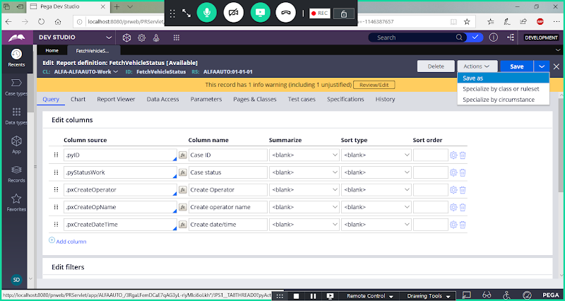

**Use Saveas Option:**

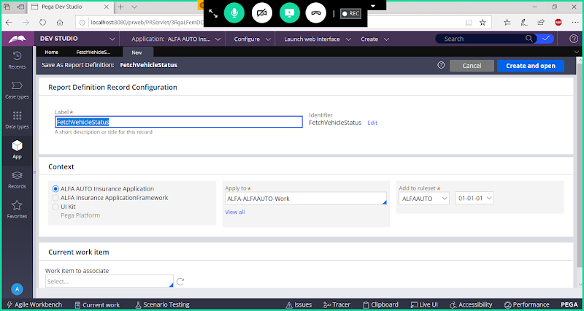

**Change Rule Name:**

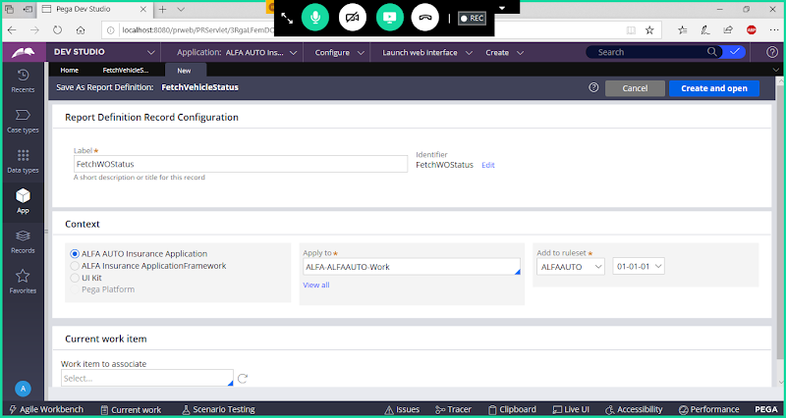

**Open**

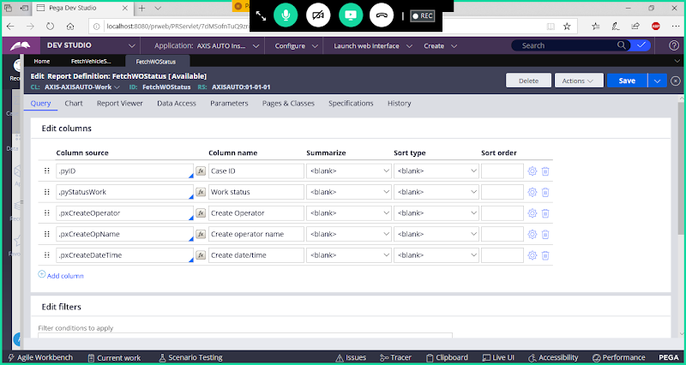

**Go to Parameters Tab:**

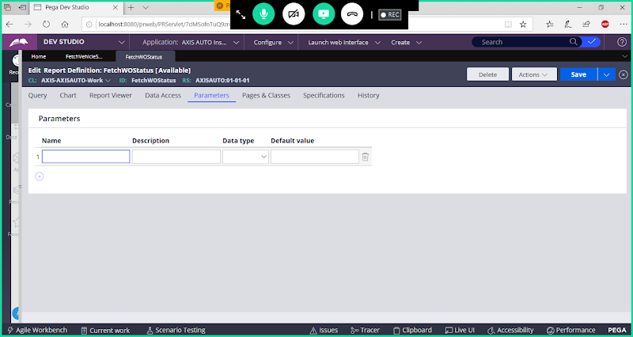

**Add Parameter Name & Set Data Type**

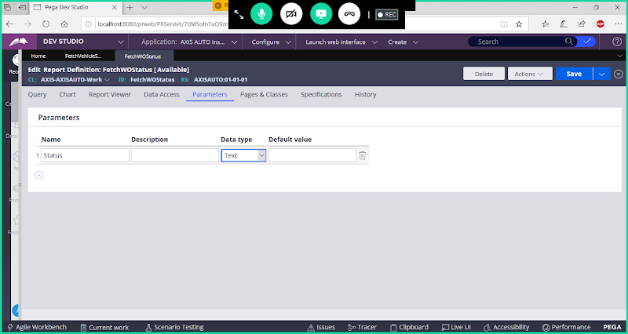

**Go  to Query Tab:**



**Go to Edit Filters**

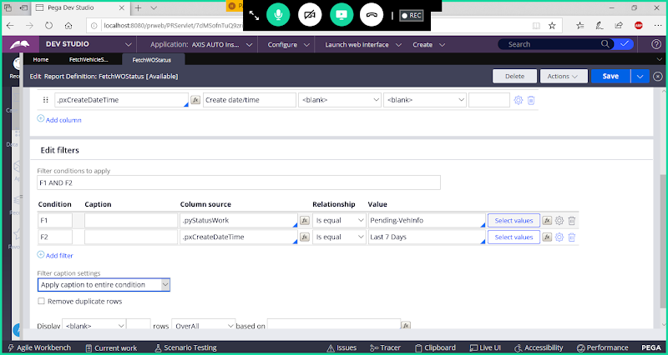

**Remove Pending-Vehinfo Value & Assign Parameter Value**

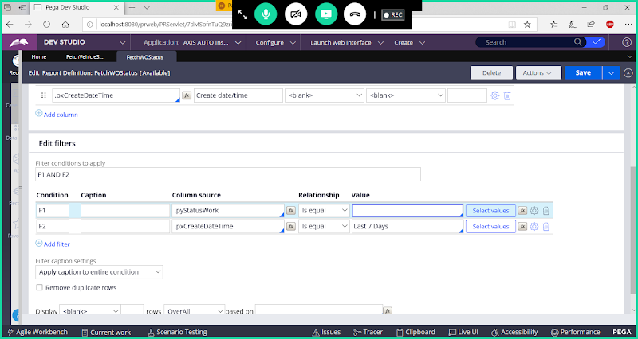

**Update Filter1 ( F1) by adding Parameter.**

**Call ur Parameter under Value:  Param.Status**

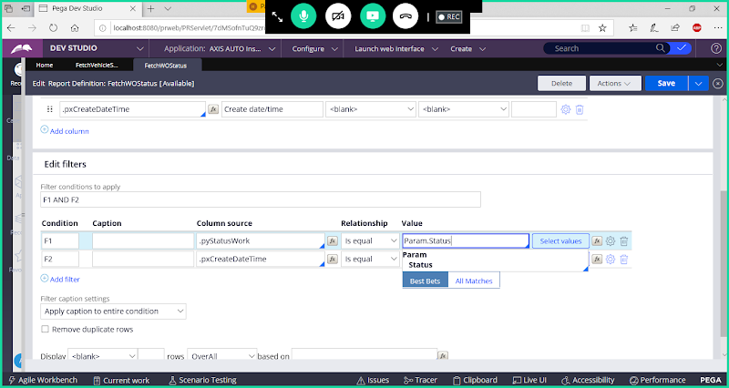

**Select Status**

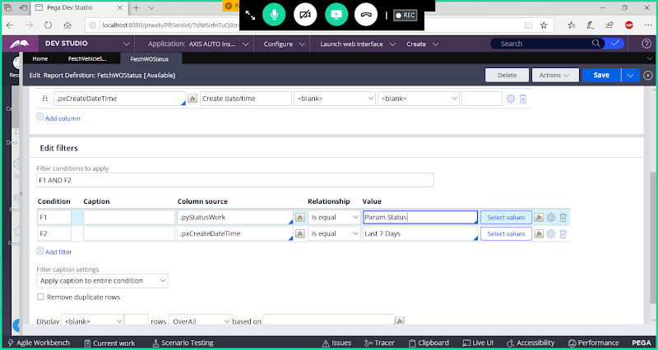

**Save Report Definition & Run Report Definition**

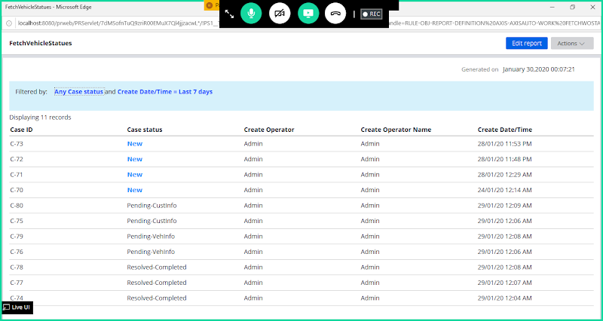

**When you run report it will show all Records with every status.**

**But Requirement is only Load Records, but don't display the Records. Records should display only when input status is Given.**

**Now Apply the setting to Empty the records when we run the Report:**

**Open Settings in Filter 1 ( F1) Condition:**

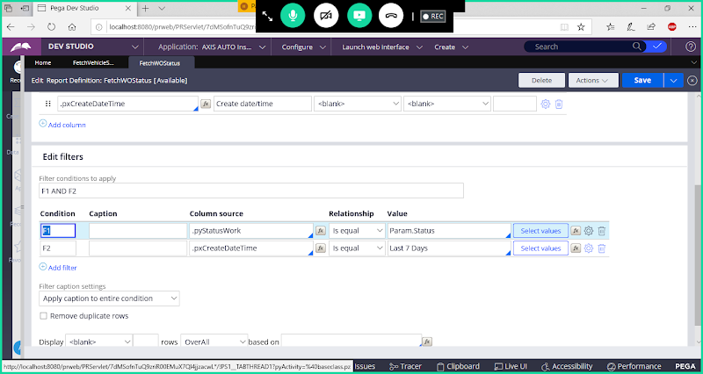

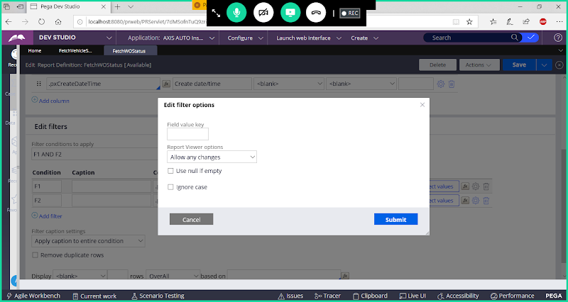

**Select Check box: Use Null if Empty & Click on Submit**

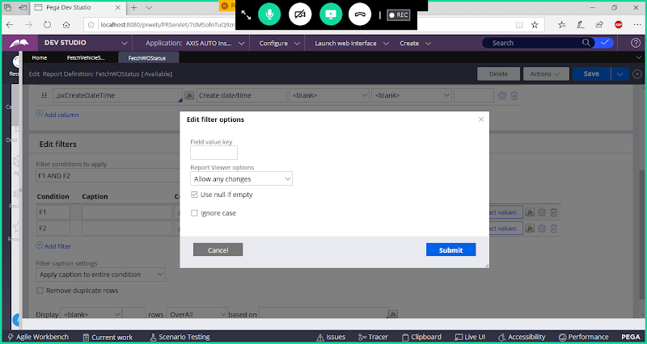

**Submit**

**Save Report & Run the Report**

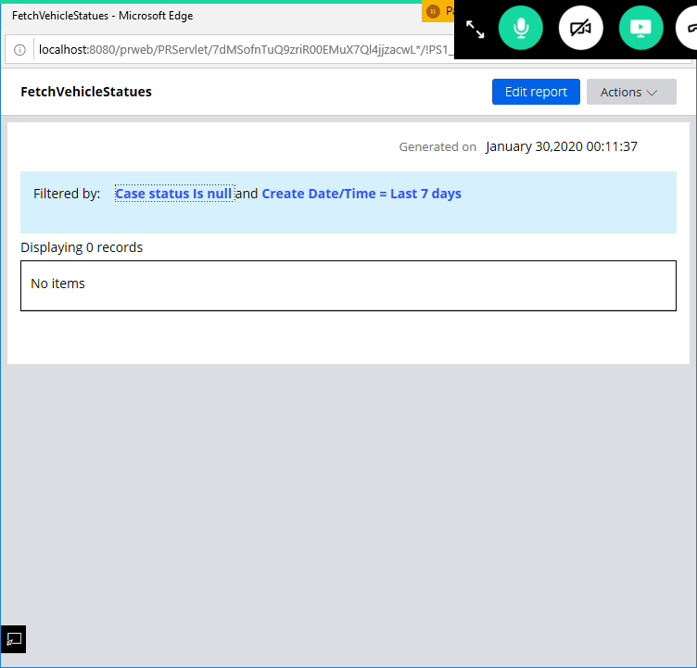

**It will not show any Records. It should display records based on Input Status.**

**Click on Filter Option**

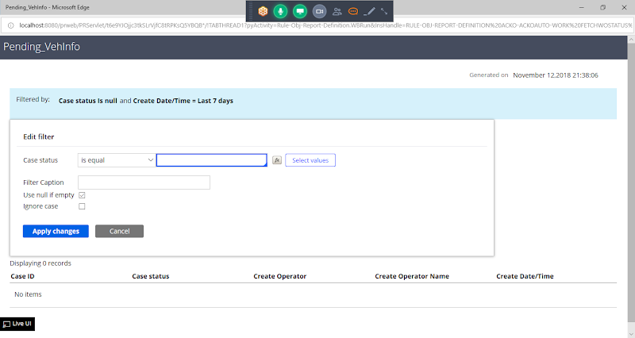

**Give Input Status Value**

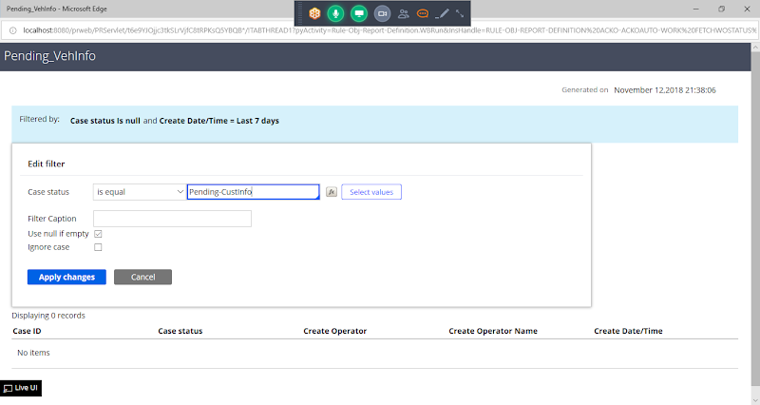

**Click on Apply Changes**



